THE SCIENCE OF ECOLOGY
Ecology is the branch of biological science concerned with the distribution, abundance, and productivity of living organisms, and their interactions with each other and with their physical environment. As a scientific discipline, it is relatively young and lacks the large body of generally accepted principles and theories that characterize older disciplines such as physics and chemistry. It has been given various definitions, including
- scientific natural history (Elton, 1927),
- the study of the structure and function of nature (Odum, 1971),
- the scientific study of the interactions that determine the distribution and abundance of organisms (Krebs, 1978).
- the study of the relationship of living organisms to each other and their surroundings (New Scientists, 1985)
- the branch of biological sciences concerned with the distribution, abundance, and productivity of living organisms, and their physical environment (Kimmins, J.P., 1987)

The choice of definition is not critical as long as it is remembered that the focus of ecology is on the interrelationships between living organisms and both their biotic (living) and abiotic (nonliving) environment.

The history of ecology dates from about the turn of the last century, but the historical roots of the subject are much older. The name for the new science was coined originally as oecology by two German zoologists, Reither and Haekle, in 1869. The word is derived from the Greek words oikos, meaning "house," and logos, meaning "the study of."

Development of ecology gathered momentum in the first two decades of this century, but most of the major advances have been achieved in the past 60 years. Only in the past 30 years has it been recognized as a major branch of biological science; Use of the word ecology was rare outside scientific circles as recently as 20 years ago. Today it is a household word. It is commonly and wrongly used as a synonym for conservation and preservation and as a banner for the "environmental movement." As a science, ecology makes no moral or value judgments about the desirability or lack of desirability of any ecological condition or event. It merely describes the ecological characteristics or consequences of things.
Ecology has its roots in natural history and has ranked alongside physiology, genetics and other disciplines as a branch of biology from about 1900. Since the mid 1950s the scope and importance of ecology have increased greatly and modern ecology is best viewed as an important interdisciplinary science linking physical, biological and social sciences.

SUBDIVISIONS OF ECOLOGY AND THE LEVELS-OF-BIOLOGICALORGANIZATION CONCEPT

There is frequently some confusion over just what ecology covers that is not already covered by other, more traditional disciplines such as botany, zoology, soil science, meteorology, and microbiology. In order to understand the unique contribution of ecology, it is necessary to understand the concept of levels of biological organization and the related concept of levels of biological integration.
If all the knowledge of biology and closely related sciences is considered, we find that it can be arranged in a hierarchy of increasing biological complexity. In this hierarchy, each level incorporates knowledge of the level below. The lowest level is that of molecules in biological systems, which is successively based on the nonbiological levels of atoms and molecules (chemistry), energy and matter (physics), and space and numbers (mathematics). Various writers have identified successively more complex biological levels of organization: subcellular components, cells, tissues, organs, organ systems, and individual organisms. These are shown, together with the traditional scientific discipline that is most commonly associated with them. Similar hierarchies could presumably be drawn up for the atmospheric and earth sciences, which emanate, together with the biological hierarchies, from the level of atoms and molecules.

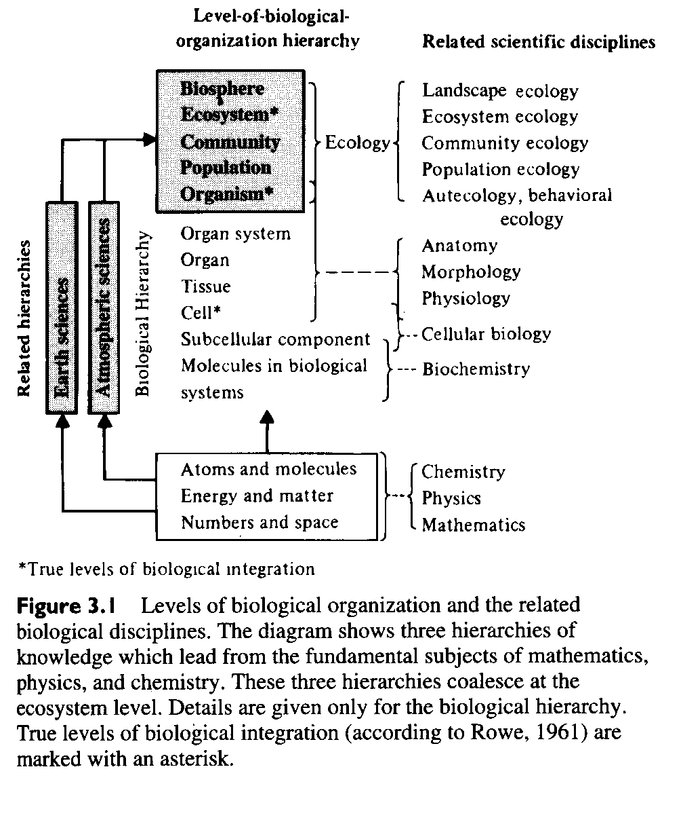

It is apparent from the Figure that almost all of the traditional subdivisions of biology are concerned with levels of organization at or below the individual organism. Ecology, on the other hand, is concerned with:

- Individual organisms in relation to other organisms and the nonliving environment,
- Groups of organisms of the same species (populations),
- Natural assemblages of populations of different species (communities), and
- Entire natural systems composed of communities and their physical environment (ecosystems).

In other words, ecology is concerned with levels of organization from the organism upward. In common with other biological disciplines, ecology knows no taxonomic boundaries. Just as the sciences of physiology, anatomy, and genetics can be applied to ferns and trees, insects and mammals, so one can study the ecology of mosses and shrubs, bacteria and birds. Ecology is a functional and organizational division rather than a taxonomic division of scientific knowledge.

The science of ecology has several subdivisions, each of which is associated with a different level of biological organization.
1. Study of the life history and the response to its environment of a single individual or species is frequently referred to as autecology: for example, the life history of an eagle, the food requirements of a deer, or the temperature tolerance of Shorea seedlings.
- Study of the abundance, distribution, productivity, and/or dynamics of a group of organisms of the same type (a single-species population) would be classified as population ecology:
for example, an investigation of competition for light and nutrients in a pine plantation, the role of disease in controlling the numbers of insects on a tree, or the rate of growth and mortality of the individuals in a salmon population.
- Studies involving the description and quantification of some aspect of a natural assemblage of different species of organisms are classified as community ecology:
for example, the study, classification, and mapping of forest plant associations or forest types, the description of the animal community in a small lake, or a study of the change in plant and animal communities in an area over time.
Population ecology and community ecology are sometimes referred to collectively as synecology.
4. Studies involving both the biotic community and its abiotic environment are classed as ecosystem ecology. Such studies may be primarily descriptive, as in the classification and mapping of different types of ecosystems. They can also be functional, such as a study of the interrelationships between the plant community and the soil, or the way in which energy and nutrients are distributed in and move through an ecosystem.

THE ECOSYSTEM CONCEPT
The term ecosystem was suggested by an English ecologist, Tansley. He defined it as including "not only the organism-complex, but the whole complex of physical factors forming what we call the environment" (Tansley, 1935). There are several alternative definitions, all proposed by American ecologists.

Lindeman (1942) proposed that "an ecosystem is any system composed of physical, chemical and biological processes active within any space-time unit."

Whittaker (1975) suggested that "an ecosystem is a functional system that includes an
assemblage of interacting organisms (plants, animals and saprobes) and their environment, which acts on them and on which they act."

Odum (1971) proposed a longer but more explicit definition.

Any unit that includes all of the organisms (i.e., the community) in a given area interacting with the physical environment so that a flow of energy leads to a clearly defined trophic structure, biotic diversity, and material cycles (i.e., exchange of materials between living and non-living parts within the system) is an ecological system or ecosystem.

It is clear from these definitions that the term ecosystem is more of a concept than a specific physical entity--a concept with five major attributes.

1. The attribute of structure (Figure 3.2) Ecosystems are made up of biotic and abiotic subcomponents. At the very least, a terrestrial ecosystem must have green plants, a substrate, and an atmosphere, and in most ecosystems, there must be an appropriate mixture of plants, animals, and microbes if the ecosystem is to function. Terrestrial ecosystems normally consist of a complex biotic community, together with soil and
atmosphere, a source of energy (generally the sun), and a supply of water.

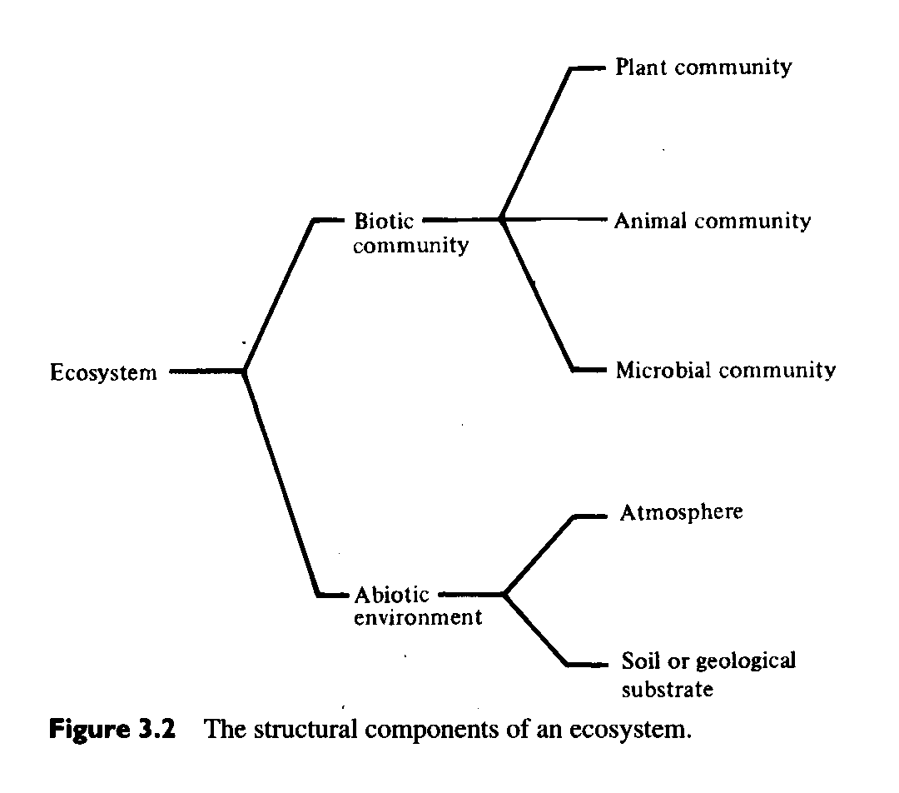
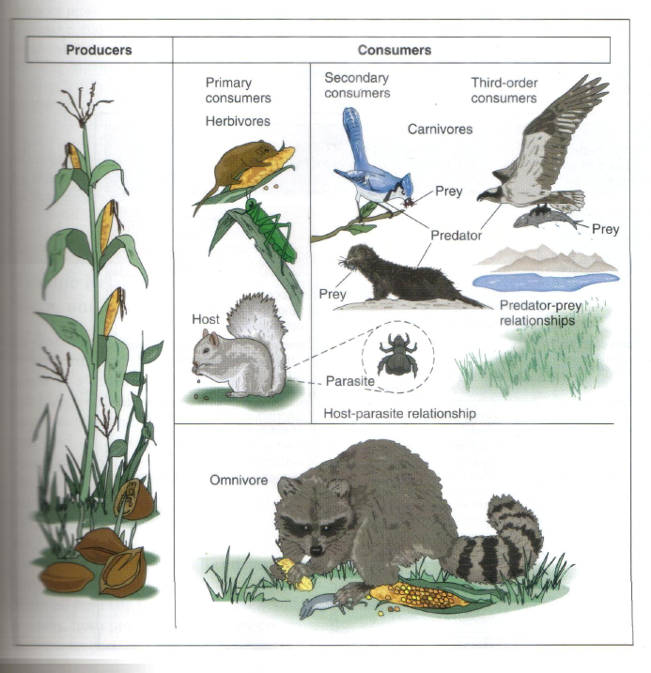

2. The attribute of function, the constant exchange of matter and energy between the physical environment and the living community. Because living and nonliving things are both composed of energy and matter, and because it is often difficult to define when organic material is alive and when it is dead, there are considerable advantages in looking at an ecosystem in terms of a physical-chemical entity. Within this entity there is a constant exchange of matter and energy between different components, some of which have the characteristics of life and some of which do not. This way of looking at ecosystems in no way denies the importance of the more traditional genetic view of life; it is complementary to it.

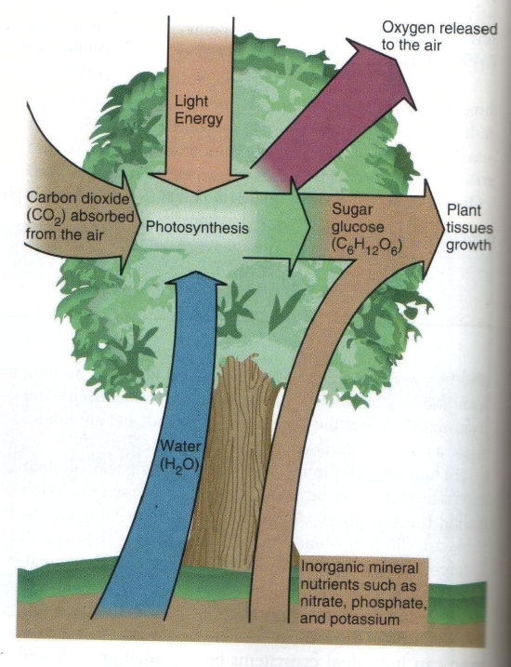
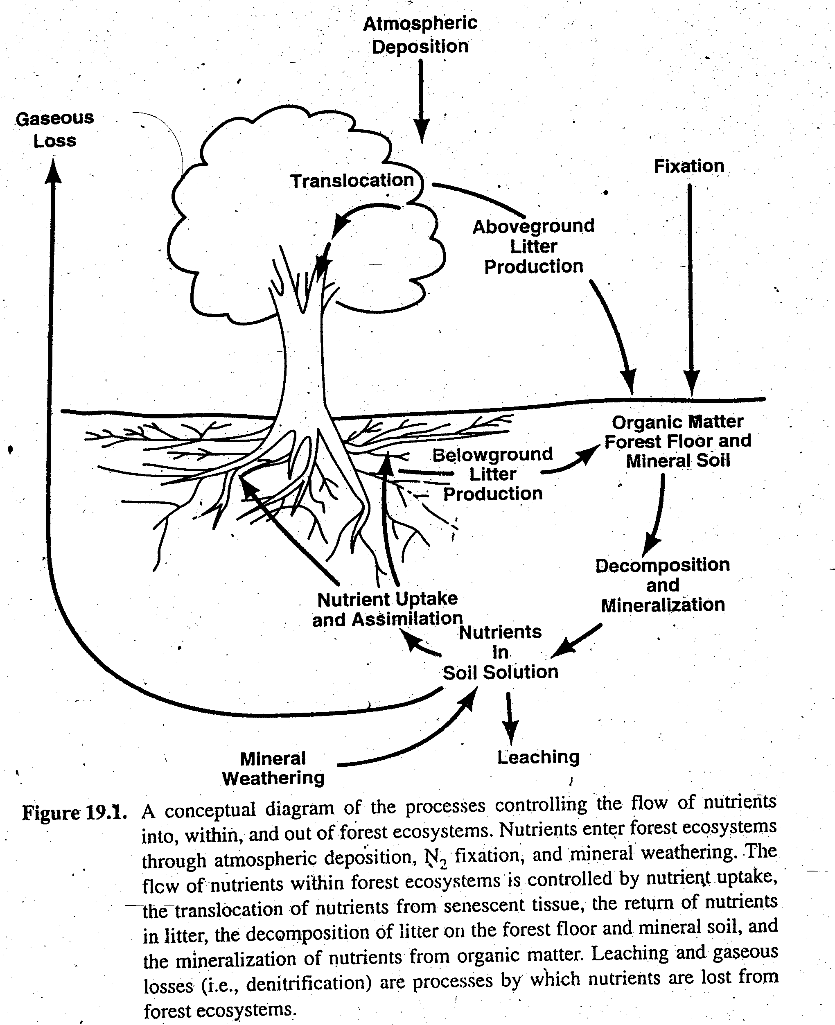

3. The attribute of complexity, which results from the high level of biological integration that is inherent in an ecosystem. All events and conditions in ecosystems are multiply determined. They are therefore difficult to predict without a considerable knowledge of the structure and functional processes of the system.

4.The attribute of interaction and interdependency. So complete is the interconnectedness of the various living and nonliving components of the ecosystem that a change in any one will result in a subsequent change in almost all the others. The extent and completeness of this interaction and interdependency led some of the earlier ecologists to think of physical examples of the ecosystem concept (e.g., a hectare of forest, an agricultural field, or a small pond) as a sort of superorganism. This view has been rejected because although. there are certain parallels between an individual and an ecosystem, the differences are too great to make the concept useful.

5. The attribute of temporal change. Ecosystems are not static, unchanging systems. In addition to the continuous exchanges of matter and energy, the entire structure and function of an ecosystem undergoes change over time.

The importance of the ecosystem concept lies in its explicit recognition of complexity, interaction, functional processes, and change over time. Its weakness lies in the
difficulty of using the concept for the identification, mapping, description, and study of specific ecosystems because of its failure to define their physical boundaries. An individual organism is a tangible entity. It has a clearly defined physical size. Populations and communities are also spatially defined entities, although their size may sometimes be rather difficult to define. A flock of birds or a school of fish constitute easily identifiable populations, but their spatial boundaries may be difficult to establish because the space they occupy may change periodically. Similarly, identification of a population of Dipterocarpus trees in the lowland rain forest or of a biotic community in the open ocean may require a somewhat arbitrary definition of spatial boundaries. However, in spite of these problems, the focus of attention in the terms population and community is clearly on a real physical entity that often can be defined quite easily. The biotic community of a clear cut or of a wet valley bottom can be readily observed and its spatial limits described. The term ecosystem, on the other hand, focuses on the structure, the complexity of organization, the interaction and interdependency, and the functioning of the system, and not on the geographical boundaries of the system.

It has been suggested (Evans, 1956) that the basic unit of ecology should be the ecosystem rather than the individual, the population, or the community.

If this is accepted, autecology becomes the study of the interactions of a single individual with its biotic and abiotic environment: an ecosystem with the organism being studied at its center.
Synecology becomes the study of a group or groups of organisms reacting with their biotic and abiotic environment: an ecosystem with the population or community at its center.

Ecosystem ecology is then left with the important jobs of studying the interactions, interdependencies, and exchanges of matter and energy between the components of the ecosystem, and of describing the temporal and spatial variations in ecosystems: a focus on the structure, functioning, and variability of the system.
By considering individuals, populations or communities within an ecosystem context, we identify the total set of factors that determine the abundance, distribution and productivity of the biological object or system of interest.

Natural phenomena exist and/or occur in natural landscapes: three-dimensional systems that have climatic, geological and biological components, and which vary in a fourth dimension--time. Consequently, we are unlikely to be able to understand and predict these phenomena unless we consider them as components of landscapes and of ecosystems.
Climate sets the overall framework for the biotic potential of an area: for example, tropical rain forest, desert, boreal forest or tundra. Within a climatic area, the landform (the shape of the landscape such as ridge top, midslope, lower slope or valley bottom), the origin of the surface materials (such as glacial deposits, water-sorted materials, wind-transported soils or organic materials), and the mineralogy of the inorganic soil matrix (for example, slowly weathering, nutrient-poor geological materials, or rapidly weathering, nutrient-rich materials) modify the climatically-set potential by determining the suitability of the substrate and the availability of moisture and nutrients to plants and animals.
The attainment of the physically-determine biotic potential depends on the types of organisms available to colonize and occupy the area: their genetic constitution (which defines their adaptations to, requirements for, and tolerances of the physical features of the environments) and how they interact with the other organisms of the area. The occurrence, distribution, abundance and productivity of any one organism are thus determined by the past and present climatic, geomorphological (landform), mineralogical, edaphic (type of soil), and biotic characteristics of the area in question.
The ecosystem concept is probably the single most important concept in ecology. Mankind must learn that we are but one species in the world ecosystem; that our activities alter the world ecosystem which is our "life-support system." Largescale alterations of atmospheric chemistry (e.g., acid rain, atmospheric CO,) will not only affect plants and other animals; they also affect us because we are a part of the ecosystem.

ECOSYSTEM CHANGE: A KEY ATTRIBUTE

In common with all living systems, ecosystems are not static, unchanging, steady-state systems (Botkin, 1990). There is continual change in their structure, function, degree of complexity, and the interactions between their components. In some types of forest, the rate of change is slow; in others it is quite rapid. In some, the change is fairly continuous and small scale. In others, it is large scale and either frequent or infrequent.

Ecosystems change for a variety of reasons: change in climate, change in soil conditions, change due to interactions between the members of the living community, and change caused by disturbances such as wind and fire. The process of change following disturbance is called ecological succession. Over time, there is a series of living communities--plants, animals, and microbes--that successively occupy and are replaced on a particular area of land, with accompanying changes in soil and microclimatic conditions. The entire sequence of community and ecosystem change is called a sere, each stage in the sequence characterized by a different community being called a seral stage.
Some of the mechanisms of successional change are caused by the plants participating in the succession: invasion of new species; alteration of the physical environment and the availability of resources (light, moisture, nutrients); and displacement of the species that were occupying the site by one or-more of a variety of between-species interactions. These are called autogenic or self-caused mechanisms. Other mechanisms that contribute to change involve disturbances that are either not related to, or not initiated by, the plant community: e.g., fire, wind, flooding, erosion, and climate change. These are allogenic mechanisms. A third category of mechanism is biogenic; these include insect epidemics, diseases, and invasions of nonnative species.
The relative importance of autogenic, allogenic, and biogenic mechanisms of succession changes from one type of ecosystem to another, and from one time to another. Allogenic or biogenic mechanisms are generally responsible for disrupting the sequence of community replacements and the environmental alterations that are the result of autogenic processes of change. Fire, wind, and insect epidemics, for example, frequently kill forests, moving the ecosystem condition to that of an earlier stage.

ECOSYSTEM DIVERSITY
It is easy to define an ecosystem conceptually. It is a group of interacting organisms (often called a community) and the physical environment they inhabit at a given point in time. It is much harder to delineate ecosystems in the real world- to decide where one ecosystem ends and another begins- because the web of interactions does not have clean breaks. Most ecologists would say that a forest and an adjacent lake are different ecosystems because the assemblages of organisms inhabiting them are almost completely different and have relatively few direct interactions.
Distinguishing ecosystems is also difficult because ecologists think about ecosystems at a variety of spatial scales. A pool of water that collects in the crotch of large tree and is home to some algae and small invertebrates can be considered an ecosystem. At the largest known scale, the earth’s entire biosphere can be considered an ecosystem.

The Values of Ecosystems
Species cannot survive in isolation from other species, they are all part of some ecosystem. Therefore, all ecosystems have value because the species they support have value.

Intrinsic value
Some types of ecosystems are rare because they occur only in uncommon environments.
e.g. Alpine areas are rare in Africa because the continent has only a few isolated mountains tall enough to support these ecosystems.
Other ecosystem types have become uncommon because of human activities. In particular, many types of forest and grassland ecosystems with fertile soils and benign climates have largely been converted to agricultural lands.
Although conservationists recognize the importance of protecting a representative array of ecosystems, they have not yet developed endangered ecosystem lists with legal status analogous to the endangered species lists of CITIES (The Convention on International Trade in Endangered Species of Wild Fauna and Flora). This is primarily because of the difficulty of classifying ecosystems.

Instrumental Values
Economic values:
If we think of the economic values of ecosystems in terms of goods and services, the material goods provided by ecosystems can generally be accounted for by summing the goods provided by various species, such as timber from tree species, food from fish species etc. It is services rather than goods that are of primary economic importance at the ecosystem level. Access to the recreational services of ecosystems is the basis for an enormous array of commercial enterprises.

Scientific and educational values:
Ecosystems are models for showing children and adults how everything can be connected to everything else.
Study on plants, animals, food chains, food webs etc.

Ecological values:
The ecological interactions that are the basis of ecosystems are absolutely fundamental to life. Certain types of ecosystems may have a significantly greater importance- keystone ecosystems, analogous to calling species with disproportionately significant ecological roles. Ecosystems can play a keystone role by providing a critical resource, such as a salt marsh providing nutrients and organic matter for an adjacent estuary.

Strategic values:
From the perspective of maintaining biodiversity at all levels- genes, species, and ecosystems- the single most essential value of ecosystems may be their strategic value. Conservation biologists have often proposed that by representative array of ecosystems, most species and their genetic diversity can be protected as well.
The strategic value of ecosystems is described by the coarse- filter- fine –filter approach to conserve biodiversity. Protecting a representative array of ecosystems constitutes the coarse filter and may protect most species. However, a few species will fall through the pores of a coarse filter because of their specialized habitat requirements or because they are overexploited. These species will require individual management, the fine- filter approach.

We need to make some distinctions that may seem to be splitting hairs, starting with habitat versus ecosystem. A habitat is the physical and biological environment used by an individual, a population, a species, or perhaps a group of species. In other words, at the species level we can speak of blue whale habitat and sequoia (Red Wood Tree) habitat, and perhaps waterfowl habitat. However, if the group of species is too broad, the term becomes so general as to be almost meaningless.
What does "wildlife habitat" mean if virtually every environment supports wild organisms? Even a parking lot will have microbes and small invertebrates living in the cracks in the pavement.

An ecosystem is a group of organisms and their physical environment such as a lake or a forest, and it may or may not correspond to the habitat of a species. A forest ecosystem may constitute the sole habitat of a squirrel, but a frog's habitat might include both the forest and a lake, and a bark beetles’ habitat might only be certain species of trees in the forest.

We can also make a distinction between degradation and loss of habitats or ecosystems. Habitat degradation is the process by which habitat quality for a given species is diminished; for example, when contaminants reduce an area's ability to support a population. Ideally, habitat quality would be estimated using parameters that are closely tied to population viability and evolutionary fitness, parameters such as reproductive rate and survivorship. The concepts of source and sinks, or cores and satellites are also useful in defining habitat degradation. In practice, these parameters are difficult to measure and therefore ecologists often only measure population density on the assumption that there will be more individuals in good habitat. However, this assumption may not always be valid (Van Horne 1983).
When habitat quality is so low that the environment is no longer usable by a given species then habitat loss has occurred. The line between habitat degradation and loss will often be unclear. For example, if degradation proceeds to a point that the local population of a species stops reproducing but some individuals can still be found (e.g., juvenile animals dispersing in search of suitable habitat in which to breed, or a few old trees that survive but whose seeds never survive) is this habitat loss or severe degradation? Sometimes these differences can be clarified if we describe the types of habitat use more explicitly, for example, by referring to breeding habitat, foraging habitat, winter habitat, and so on.

Ecosystem services
- moderate weather extremes and their impacts
- disperse seeds
- mitigate drought and floods
- protect people from the sun's harmful ultraviolet rays
- cycle and move nutrients
- protect stream and river channels and coastal shores from erosion
- detoxify and decompose wastes
- control agricultural pests
- maintain biodiversity
- generate and preserve soils and renew their fertility
- contribute to climate stability
- purify the air and water
- regulate disease carrying organisms
- pollinate crops and natural vegetation

